**Mision 0**

**How to use:**

1. Run the program after compiling the code (File Mision0.c)
2. A menu will show up  
   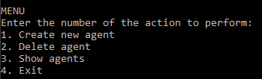
3. Type the number of the option you wish to perform and press ENTER

**Option 1:**

If you choose the option 1 (Create new agent) follow these steps:

1. Enter the name of the agent and press ENTER
2. Enter the last name of the agent and press ENTER
3. Enter the age of the agent and press ENTER
4. After doing that it should look like this and display “Enter the amount of missions of the agent:”  
   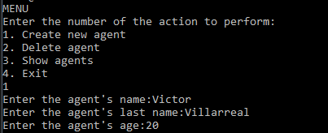
5. Type the number of the amount of missions you wish to add to the agent and press ENTER
6. Enter the code for each of the missions to be added and press ENTER after typing each code   
   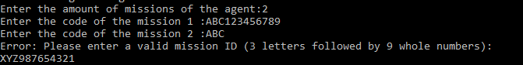
7. If a mission ID is invalid, type the correct ID in the accepted format (3 letters followed by 9 digits) and press ENTER
8. Type the number of the amount of actives you wish to add to the agent and press ENTER
9. Enter the code for each of the actives to be added and press ENTER after typing each code   
   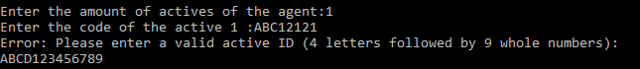
10. If an active ID is invalid, type the correct ID in the accepted format (4 letters followed by 9 digits) and press ENTER
11. The agent should be added successfully
12. The menu will now show up again waiting for new instructions  
    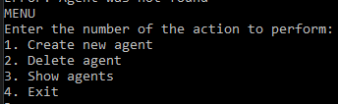
13. Type the number of the option you wish to perform and press ENTER

**Option 2:**

1. Enter the name of the agent to be deleted and press ENTER  
   
2. Enter the last name of the agent to be deleted and press ENTER  
   
3. If the agent was found in the list (must be previously created with option 1) it will show a message saying the agent was deleted successfully  
   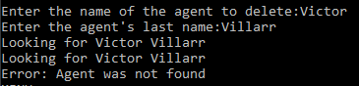

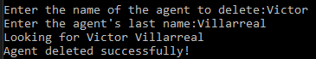

**Option 3:**

1. After typing 3 and pressing ENTER from the menu, a list of current agents will be displayed with their respective data (each agent must be first created with option 1)

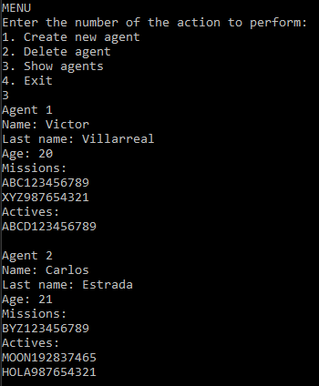

**Option 4:**

1. After typing 4 and pressing ENTER from the menu, the program will be exited